FRIENDS FOREVER
HOLIDAY BRUNCH

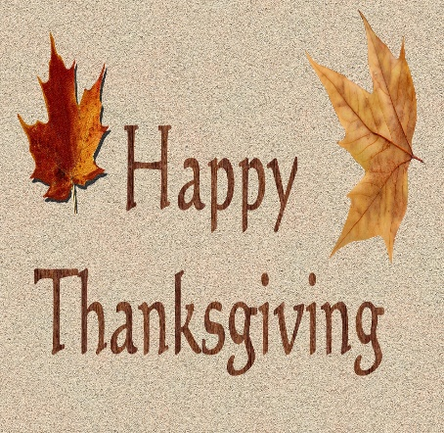
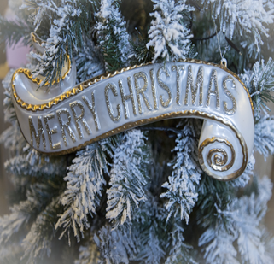
You’re invited to our Girl Scout Holiday Brunch hosted by Friends Forever Alumnae group.
November 13, 2023
10am – 1pm
At the St. Paul Girl Scout Service Center
400 S Robert Center
St. Paul, MN
Please bring a dish to share, beverage provided.
We’re continuing our support for Neighborhood House. Please bring female care products, paper products or even baby care products to be donated. RSVP Bonna, bscherer45@yahoo.com

